SQL Assignment – 5
D2_83822_Rohit
Relational and Logical Operators.

1) Write a query that will give you all orders for more
than Rs. 1,000.

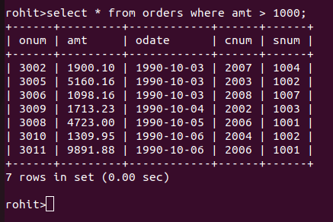

2) Write a query that will give you the names and cities
of all salespeople in London with a commission above
.10.

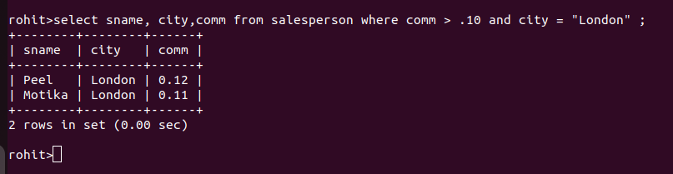

3) Write a query on the Customers table whose output
00000000000000000000000will exclude all customers with a rating <= 100, unless
they are located in Rome.

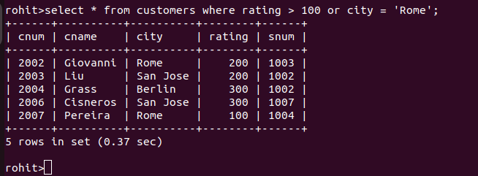

4)
What will be the output from the following query?
Select * from Orders
where (amt < 1000 OR
NOT (odate = ‘1990-10-03’
AND cnum > 2003));

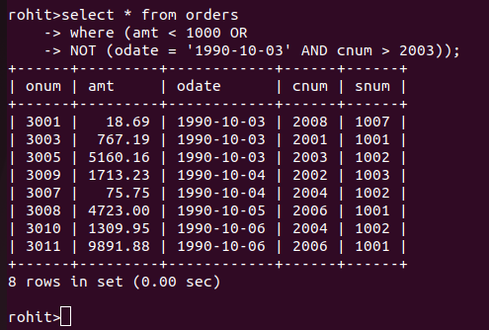

5)
What will be the output of the following query?
Select * from Orders
where NOT ((odate = ‘1990-10-03’ OR snum
>1006) AND amt >= 1500);

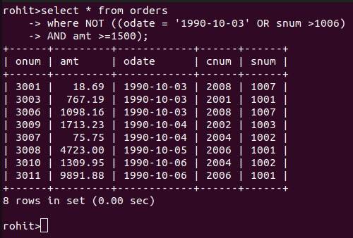

6)
What is a simpler way to write this query?
Select snum, sname, city, comm From Salespeople
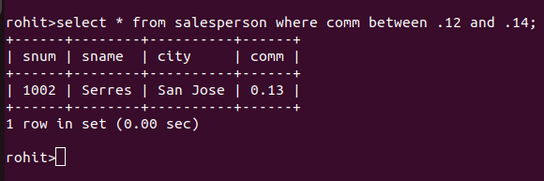
(comm > .12 OR comm <.14);

